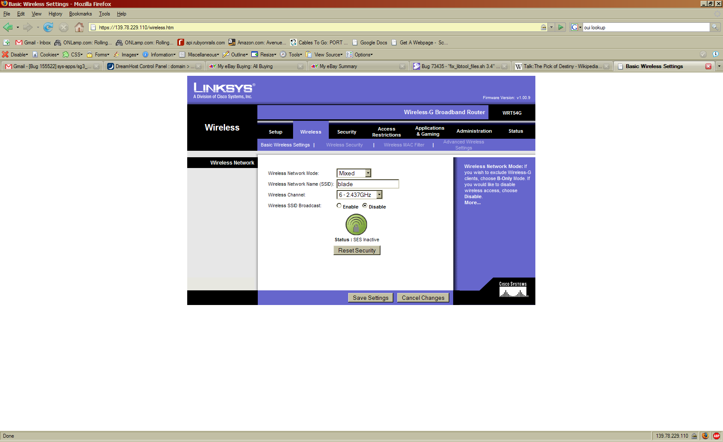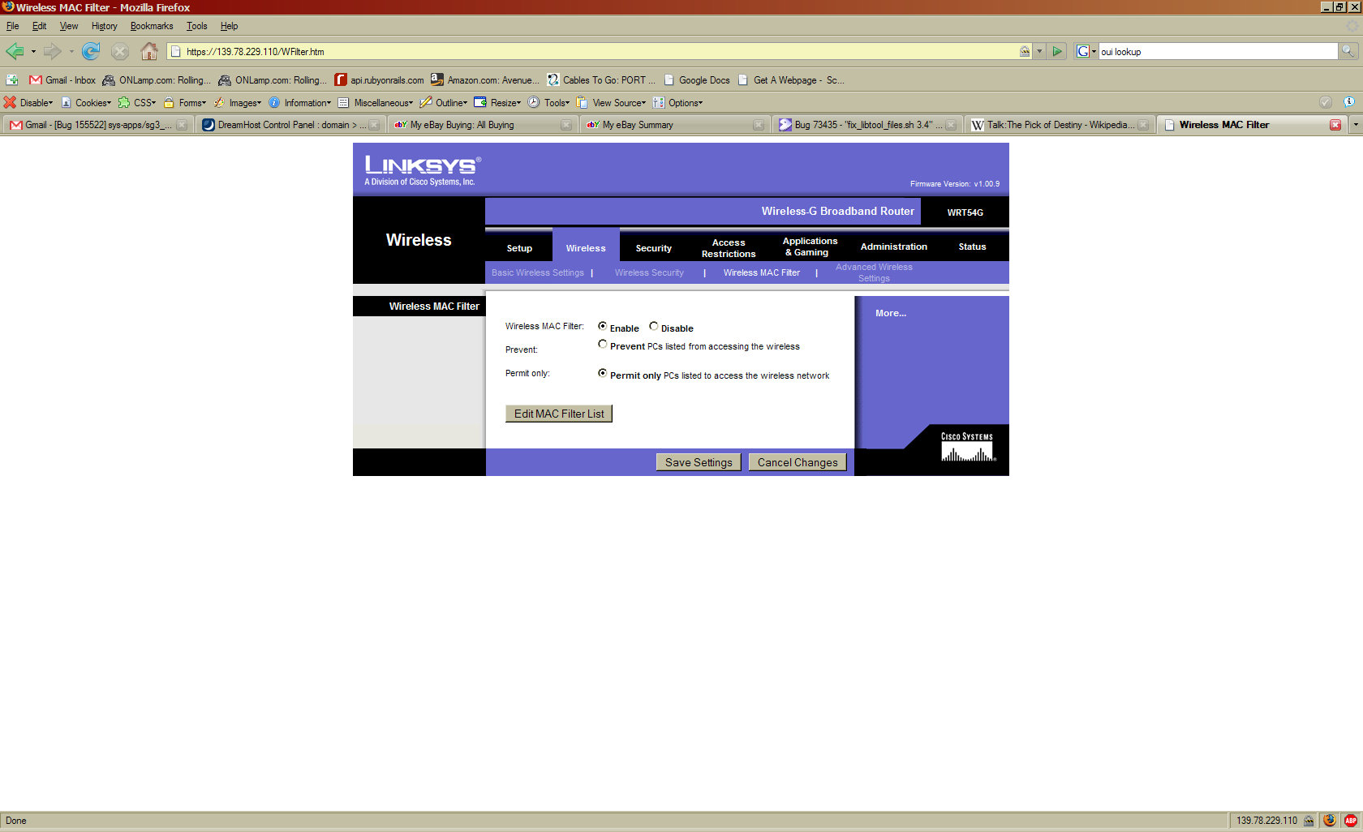
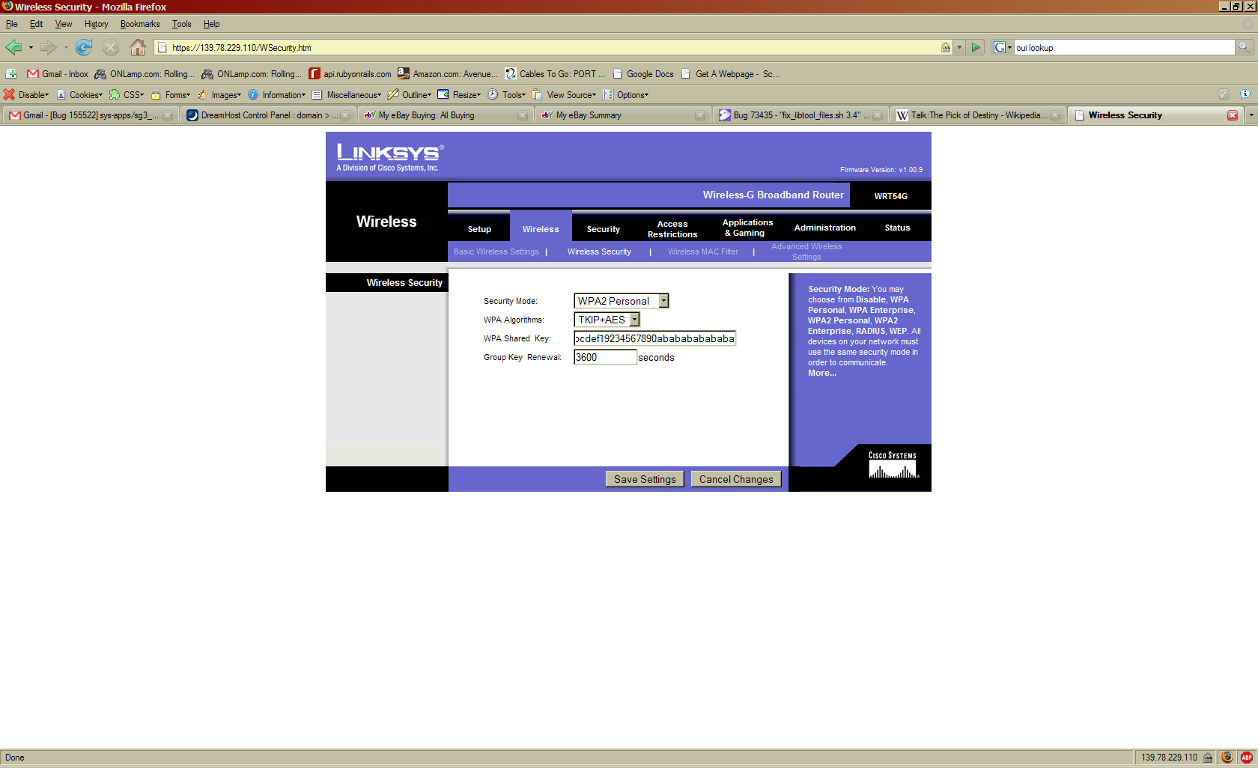

…cannot continue – no WiFi cards installed.

Summary
I don’t own a Linksys router. But, I do know someone who does. There are no WiFi cards installed in this machine so I am unable to test that it works. Anyway. I noticed that the router supports WPA2, which is great, because if Shaun’s wardrives pull up as many low-security WEP access points as they do, we need something better. WEP sucks, and we need to move on up to something that’s a lot more secure, like WPA or WPA2. Maybe someday these routers will come bundled with WPA/WPA2 on by default rather than being “an option”.

